I. Introduction
For people experiencing homelessness, fragmented systems of care, limited access and structural racism create barriers to appropriate health care for persons experiencing homelessness. Basic day-to-day survival often makes health not a priority, causing delays in care and worsening health. Clinical practice guidelines are essentially the same as people who are housed, No person experiencing homelessness should receive a standard of care that is less. However, when addressing health and illness among persons experiencing homelessness you have to take into account comorbidities, impacts of lack of housing, lack of privacy, and societal barriers when planning care.
One way to improve access and diminish barriers it to provide care in shelters. There are many models that have been used by Health Care for the Homeless (HCH) agencies over the years. One of the most practical ways to initiate shelter health is shelter-based health care (SBC), including routine team shelter visits.
Shelter Based Health Care – Benefits to Shelters and to People Experiencing Homelessness
Shelter-based health care (SBC) provides our homeless neighbors with ease of access and improved access to the health care system. It repairs a hole in our system, strengthens the relationship between the person experiencing homelessness and the health system and levels the playing field. SBC also helps to reduce individual barriers to health by acknowledging lack of mobility, the patient’s hierarchy of needs, and potential inability or unwillingness to follow through.
When providers are present on site where patients live, they can address medication safety and improve communication between health teams, clients, and shelter staff. On site visits by an enthusiastic HCH team also eliminates the routine degrading judgement homeless persons face when presenting for care. Health care providers can also work with shelter staff and increase their health literacy and support understanding that even in a “housing first” environment, health is an equal priority.
ADD BENEFITS TO SHELTER

Guiding principles
- Human rights-based. Equality, respect, kindness, equal power, participant centered. Patients have the right to choose of when, where, and how health care is delivered.
- Low-barrier shelters and care: Housing first and decarceration
- Outreach is incredibly important to the person and to healing homelessness.
- Respect and engagement of residents in decision making
- Strengths-based. Identify and build on skills they have, gives tools to move from illness to wellness, involves realistic plans and expectations
- Harm reduction. Reduces harm, provides services that do not condone or condemn behaviors.
- Trust. Providers continually works on trust-building. Providers, nurses, CM all do what they say, and continually look to follow up with the participant
- Trauma informed. Homelessness is trauma, and there is trauma on the path to homelessness. Outreach in care works to avoid re-traumatizing.
- Goal-oriented. the patient’s goals in addition to our goals (QI, standards, screens and shots, etc.) given the level of acuity, can’t do it all at once but can plan to do it. That is why every patient is given a follow up plan and follow up appointments at each visit.

Unhoused individuals and families are especially vulnerable to COVID-19
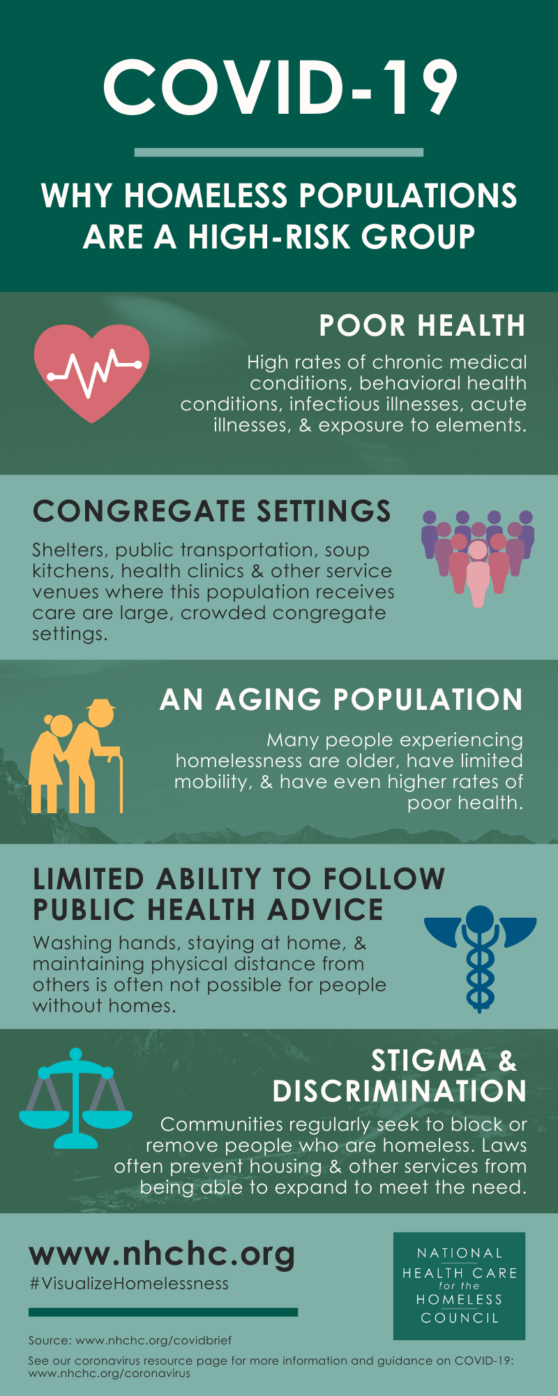
Many people experiencing homelessness are either living in congregate settings or encampments and have limited ability to follow public health guidance on social distancing. There is also a high proportion of the population of people experiencing homelessness that have risk factors for COVID-19 both in terms of age and underlying health conditions. People experiecing homelessness also face trauma, stigma and discrimination. In Chicago, as across the country, most people experiencing homelessness are people of color, and are at higher risk for COVID-19 due to structural racism and limited access to care.
Specific unhoused populations with distinct needs (particularly during a pandemic)
- Medically and structurally vulnerable
  - Those at high-risk for COVID, People with disabilities, People who are pregnant, etc.
- Persons with Serious Mental Illness (SMI) and/or Substance Use Disorder (SUD)
- Unsheltered homeless
- Families, including “doubled-up”
- School-aged children
- Unaccompanied minors/youth
- Postsecondary students
- Survivors of domestic violence
- Veterans
- Undocumented folks

II. Checklist for Shelter-Based Care and Checklist for Shelter Staff
To be finalized when the content is complete
DRAFT - Key Components of Partnerships between Health Care Providers and Shelters
Role of medical partners
- Partner with Chicago Department of Public Health (CDPH) and existing Healthcare for the Homeless (HCH) providers (Heartland Alliance Health and Lawndale Christian Health Center).
- Include People Experiencing Homelessness in Planning.
- Outreach and Engagement with shelter residents and staff. Onsite work with the shelters is important for assuring staff and residents.
- Dedicated point of contact for the shelter’s medical needs and helping to refer and connect residents to
- Follow Healthcare for the Homeless Standards of Care as presented in this document.
- Deliver CDPH and CDC guidance on infection control, personal protective equipment (PPE), quarantine/isolation (Q/I), etc.
- Guidance on use of PPE: Provide guidance and training to shelter staff about correct use of PPE.
- Help to identify clients at increased risk of severe disease.
When there are possible residents with COVID-19 symptoms:
- Work with CDPH and existing testing teams to test people with COVID-like symptoms who are not considered at high risk of severe illness and do not require hospitalization (anyone meeting either criteria should be transferred to ED immediately).
- Assist the Rapid Testing Team in screening clients at your shelter if there is a case or cluster of cases detected.
When there are confirmed COVID-19 cases among residents or staff:
- Clinically triage people to City Q/I facilities if required.
- Review COVID+ clients regularly for signs of clinical deterioration.
- Teach shelter staff to look for signs of deterioration.

III. Outreach and Engagement
Dr. Pabalan and Dr. Lui have provided resources to add more on families/youth
Outreach: Key Components of Shelter Health
- Healthcare Provider Orientation
- Needs Assessment
- Safe, Private Space
- Consistent Service Delivery
- Engagement - Residents, Shelter Staff and Administration, and Healthcare Providers
A. Healthcare Provider Orientation - Tips from long-time Healthcare for the Homeless providers
- Establish a regular schedule and stick to it.
  - Don’t rely on asking shelter staff if there is a need for you to go. If you call on the day you are to come and ask, “Is there anyone there who needs to be seen?” – Most of the time, staff will say no, and if you don’t come, you won’t have a chance to help. It is much better to come on a regular schedule.
- Provide medication on the same day. Be prepared to test and treat on site when possible.
  - Don’t just provide a written prescription for medication. Find processes to provide the medication immediately or to have it delivered the same day.
  - Even if the person is referred to the emergency room for a problem, always give medication that they might need. For example, always give antihypertensive medication (like amlodipine) even if you refer to the ED for an hypertensive urgency/emergency. Most EDs do not dispense medications, and the person will leave without the medication that they need.
  - Even if you refer to dental for pain or an abscess, start treating with an antibiotic/NSAID if indicated. Don’t wait for the dentist to do it.
  - Do not refer a person with a urethral discharge to a clinic – Lawndale Christian Health Center did a study, and half never made it. Test and treat on site immediately. Carry with you azithromycin, injectable ceftriaxone and lidocaine for reconstitution. Carry metronidazole with you to immediately treat trich if person says their partner told them they had it.
- Engage providers with expertise in Substance Use Disorders
  - Have ways to refer patients for substance use treatment including buprenorphine and methadone.
  - It should be a very rare exception to prescribe a controlled substance other than buprenorphine/naloxone in large congregate settings. This pertains especially to benzodiazepines. Word gets around quickly and meds are easily stolen.
  - Don’t give up on someone who is high or nodding off. Gently say we can talk later, and give your business card so the person knows where they can get help.
- Patient engagement and education in shelter-based care
  - Don’t take a person’s irritability personally. You may represent a medical system or race/privilege that may have harmed them in the past. Or it could just be part of their mental illness or personality disorder - in that case, the person’s behavior can help you do diagnose what is going on, so it can actually be helpful if you step back and observe the interaction as if you weren’t in it.
  - Avoid confrontation. Motivational interviewing techniques can be more effective and more fun for you and the patient.
B. Needs Assessment at the Shelter
Before you begin to have a health team on site at a shelter, it is recommended that a needs assessment is done. Speak with shelter staff and management interested in collaboration. Find out:
- What services persons experiencing homelessness desire
- What services are available on site, what agency provides them and how often are they available
- What times are the majority of guests or residents on site?
- How have participants of their program been accessing care and at what sites, what has worked and what has not worked
- Specific needs for participants and/or staff
C. Safety First – Providing Trauma-informed Care
Providing Trauma informed care in shelters respects the experiences that people may have had in their lives and provides for emotional, physical and psychological wellbeing.
- Are there spaces available that are respectful of patient privacy?
- Is it quiet enough for normal conversation?
- Is the space free of dim lighting, chemical smells, and disruptive behavior?
- Do proposed spaces have a clear exit?
- Will efforts on side be collaborative and coordinated?
- With the above in mind, how and where would waiting, registration, and care spaces be used?
For more information see the following guide: https://nhchc.org/wp-content/uploads/2019/08/creating-a-culture-of-safety-at-health-centers.pdf

D. Consistent Service Delivery
- Give Consumers a voice. Honoring the voice of those experiencing homelessness also gives dignity and acknowledges the rights we all have in planning our healthcare, it breaks down barriers and brings people into the health care space., and encourages engagement in care
- You have to OWN IT – As a provider in shelter-based care you have to own the health of the community in your shelter. That does not mean you have to do all things for all people but you do have to see that every resident/patient/guest has access to services.
- You need to sell healthcare for the homeless services to the shelter and important stakeholders-in their systems.
- Get to know the case managers, shelter workers, etc. where you are. They will be your advocate with participants.
- Do rounds in the gathering area, and meet and greet clients. Get out of the area where you see patients. You can learn so much more by not secluding yourself.
- Consider placing your registration person/medical assistant in view of people in the gathering area. This can be an effective way to have people wonder why you are there and what you are doing. It can also be helpful for the registration staff or medical assistant’s feeling of safety if they are seen out in the open.
- No does not mean no, it means I do not trust you. Keep doing rounds and speaking with people. It just means you need to do more work on engagement.
- Especially for people with serious mental illness, continue with friendly engagement – no need to ask about mental health symptoms every time. Find something in common to talk about - sports, the weather, the person’s birthday, the holidays. If you see them on the street, chatting people up and buying a meal can go a long way to engaging into care.
- For people with psychosis who could really benefit from taking an antipsychotic, find the hook or the symptom that is really bothering them and propose that medication may help to decrease that symptom. The symptom could be problems with sleep, with voices that are too loud and bother them, problems with concentrating on getting things done, problems with finding housing, etc. Less helpful is medicalizing/labeling the person’s symptoms as hallucinations, etc. “What do you think I am, doc, crazy??”
- Give all patients, especially those in shelters, follow up visits. Our patients have so many complex health issues that it is difficult to keep on top of them, so no one should get a RTC as needed. Most importantly telling our patients, who are isolated and invisible, that you want to see them again is giving them worth, and hope.
- Using wallet sized cards are more likely kept than 8.5 x 11 handouts. Business-sized cards can be used to record: TB test results; rapid HIV test results; blood pressure readings; (maybe SARS-CoV-2 test results?); stop smoking information; insurance information including ID numbers; clinic appointment cards. If you don’t have one of these specialized cards, you can always write the information on the back of your personal business card.
- Be consistent and keep your word. There is no cancelling sites, in emergencies reschedule, but being consistent is outreach. At times you may not have a medical assistant but that is ok as long as you can work on paper and fax or email forms. The alternative is an on-call assist.
E. Engagement
Engagement happens through successful outreach- patients buy in to primary care, and behavioral health services, work with multiple, consistent encounters. All sustainable efforts in shelter health are based on engaging participants in care. You cannot engage them without laying the groundwork first. Outreach is the process of building connections that will improve the life and health of PEH and can occur in any setting where there are persons experiencing homelessness. Outreach works to address health equity and human rights right issues through participant centered interventions and choice. In shelter health patients have the right to choose of when, where, and how health care is delivered. Once a conversation is had with the health team a person can receive care in the shelter or schedule in the clinic. Engagement involves multilevel commitment.
Shelter Staff Engagement
- Historical high rates of turnover
- Be gracious in understanding their limitations related to funding, shelter scopes of services and individual education
- Provide training for all levels of shelter staff: admin, CM, Front Desk
- Trainings should address their concerns and priorities first then ongoing public health issues
- The more shelter providers are engaged in the physical and behavioral health of your participants the more they will advocate and reinforce follow through
- Sometimes shelter staff are only a couple steps removed from the shelter guests they are serving and have similar traumas and needs. Occasionally it will be necessary to take a staff member’s blood pressure or do their TB test, even if the team is there to see guests. This is worth the time if it doesn’t become too much.
Health Team Engagement
Providers of services in shelters need to be supported, to have the tools and team members needed to deliver a consistently high standard of care
Patient Engagement
- Human rights-based. Equality, respect, kindness, equal power, participant centered. Patients have the right to choose of when, where, and how health care is delivered.
- Strengths-based: Identify and build on skills they have, gives tools to move from illness to wellness, involves realistic plans and expectations
- Reduces harm, provides services that do not condone or condemn behaviors. Provides education, and continually works on trust-building. Providers, nurses, CM all do what they say, and continually look to follow up with the participant
- Trauma informed: homelessness is trauma, and there is trauma on the path to homelessness. Outreach in care works to avoid re-traumatizing.
- Goal-oriented: the patient’s goals in addition to our goals (QI, standards, screens and shots, etc.) given the level of acuity, can’t do it all at once but can plan to do it. That is why every patient is given a follow up plan and follow up appointments at each visit.
- Sometimes activities that aren’t strictly medical can help to create staff and client/patient engagement. Christmas parties with practical gifts; foot-washing and giving out socks; pizza parties;

IV. Scope of Services
A. Physical health, behavioral health, and wrap around care
The care team for persons experiencing homelessness includes:
- Persons experiencing homelessness
- MD/APRN/PA: Physical health, SUD, Psychiatry
- RN
- Behavioral Health
- Case Manager
- Benefits Enrollment
- Housing
- Care Coordination
Although it is ideal, not all services need to be from the same organization and not all persons need all services but they do need to be evaluated for them. Clear assignments from health centers on available staff and clear linkages with shelters can provide these essential services.
3 levels of service delivery
- Intensive sites: Integrated teams with behavioral health and physical health providers, medical assistants, Benefits enrollment, CM. At maximum this is a shelter-based clinic but could also be weekly or biweekly visits for a full or half day.
- Less intensive sites: Physical health provider, medical assistant, and ability to refer to behavioral health and other wrap arounds.
- Community engagement sites: Screenings and flu fairs, etc. Community health worker visits.

Preparing for services to be offered in the shelter
- Talk with consumers and ask them what they need and what they want. Find out what services they will be open to receiving on site at the shelter
- Be clear but know that successful shelter care can morph- start simple offering one time per week to every other week.
- Space will impact scope of services:
  - Comprehensive care
  - Physicals
  - Women’s health exams
  - Urgent care
  - Management of chronic disease
- Linkage for lab testing, EKG, spirometry, immunizations
- Medications- what will health care agency provide for uninsured (examples to follow in supplies section)
- Be prepared for emergencies and frequently check expiration dates: epinephrine SQ; nasal or injectable naloxone; diphenhydramine for acute allergic reaction; glucose gel for hypoglycemia; chewable aspirin 325 for acute chest pain; NTG SL for acute chest pain (but expires quickly); albuterol inhaler for asthma attack; captopril or amlodipine for hypertensive urgency; mouth shield in case rescue breathing needed; if with a clinic room within a shelter site, consider access to AED
Be consistent: there is no cancelling sites.
PEH are consistently let down by the system, in truth the system is overwhelmed and many agencies and providers over promise, others just do not follow through. It is our charge to follow through. Health centers engaged in homeless services need to plan for time off, even unexpected time off. Never cancel, always reschedule. If you or your team is providing services every other week and there is no room for an extra day or extra team, add an hour the next scheduled visit, offer telehealth, send the RN or CM to gather information needed for follow up. If care is cancelled, then trust is broken. Repair is difficult. At times you may not have the full team on site, if safety can be assured, care should be provided on site. It is reasonable to limit services in low staffing situations but first try to do them differently.
B. Behavioral Health Scope of Services:
- SBIRT for all, even at first visit. CV disease, cancer and COPD are still the biggest killer of persons experiencing homelessness, and 50-80% of people smoke, so addressing smoking and cessation is important; assessing for SUD and AUD important
- Asking about hearing voices outside of you that bother you, or seeing things that really aren’t there (AH, VH) are high-yield questions when doing the review of systems.
- PHQ-2 is also high-yield.
- With psychiatry input, strongly consider initiation and use of long-acting injectables on site at shelters for those with psychosis who have difficulty taking PO meds – keeping clinic appointments to receive IM injections can be a challenge for those who need LAIs
- Emphasize motivational interviewing techniques for all team members, and model techniques for all staff
- Model and practice de-escalation techniques. Get on the side of the patient and fight with them against the system. “You are right, it isn’t fair, but we will fight along with you.”
- Do harm reduction for everyone with OUD (prescribe naloxone, don’t use alone, don’t go to pass outs, needle exchange); have a very low barrier for starting medication assisted treatment/recovery; don’t just refer to the clinic; carry rapid urine toxicology cups with you, but urine testing is NOT required for the diagnosis of OUD; schedule soon 2-3 day follow-up after starting. Word will get around if you are low-threshold OR if you put up a barrier such as making people see a counselor or go to clinic first.
- Don’t start with telehealth. Telehealth can be incorporated as a part of behavioral healthcare but establishing an onsite presence is the core approach.
- Referrals – link person to see a “counselor” (not a therapist or psychologist or psychiatrist, at least at first), and link an appointment to seeing them with what the person is looking for, such as an ID, housing, other services
- Consider use of recovery coach or other peers to lead in engagement – may be especially effective on “smoke breaks”
C. Supporting access to disability and public benefits
Add this section
D. Health education
Add this section
- Don’t put students (nursing, medical or other) in a position to do health education all by themselves. A seasoned staff member/provider is needed to “rescue” the student from too personal questions (What’s your phone number? Are you married?) or to answer questions that the student may not have the answer to.
- Try to coordinate very brief (10 minutes max) health education with a specific service that happens immediately thereafter, such as flu shots, TB testing, Hep A immunization, coronavirus testing? Pay close attention to literacy level of any handouts and make them brief. Vague education about reducing cardiovascular disease or a diabetic diet makes little sense if a person has little to no control over their diet or exercise. Link education to what is happening in the shelter – if many of the kids have diarrhea, do education about that.
E. Roles for Students
Taylor and students to add content here
F. Interagency collaboration – section to be added

For specific services related to COVID-19, see Section VI below.

V. Clinical and Case Management Workflows and Protocols
Jess working to compile examples received
Care flow
Care team
Supplies
Supply lists include but are not limited to the following
  - PPE-
    - For COVID-19 Care and Testing
      - N95
      - Face Shield
      - Gown
      - Gloves
    - For general care :
      - Surgical Mask
      - Face shield
      - Gloves
  - Hand Sanitizer
  - Cleansing wipes for surfaces
  - Alcohol pads for cleaning medical equipment (they are sensitive to bleach-based products)
  - Gloves
  - Wound care supplies
  - Condoms
  - Narcan
  - Be prepared for emergencies and frequently check expiration dates: epinephrine SQ; nasal or injectable naloxone; diphenhydramine for acute allergic reaction; glucose gel for hypoglycemia; chewable aspirin 325 for acute chest pain; NTG SL for acute chest pain (but expires quickly); albuterol inhaler for asthma attack; captopril or amlodipine for hypertensive urgency; mouth shield in case rescue breathing needed; if with a clinic room within a shelter site, consider access to AED
  - Point of care testing supplies: Blood Sugar, A1c, Rapid strep, Rapid Flu, dip UA, Urine Pregnancy, Hemoglobin, Rapid HIV
  - BP Cuff, otoscope/ophthalmoscope, pulse ox, thermometers
  - Ear irrigation with H2O2; 10 blades for callus trimming; heavy duty nail clippers; 11 blades for I and D; STI and regular culturettes, urine cups for cultures
  - Socks, reading glasses, basic toiletries
  - Common medications for the uninsured: include basic OTC such as acetaminophen, ibuprofen, alcohol free cough syrup, allergy medications, and basic meds for managing DM, HTN, Cholesterol, Skin issues; consider using pre-packaged medications from companies such as PDRx (pdrx.com)

Partnering with Shelter Staff and Volunteers

VI. Healthcare supporting pathways to Permanent Supportive Housing
Add this section
- Coordinated entry
- Disability letter
- Advocacy
- Referrals and care coordination
- Other

VII. COVID-19: Providing Care During a Pandemic
A. Assuring staff and participants, providing guidance on infection control and PPE
Clinical staff will provide ongoing PPE training for shelter staff, consult on appropriate social distancing, sleeping and eating arrangements and sanitation. It is suggested that during a pandemic, this should be ongoing weekly. The most recent guidance from the Centers for Disease Control and Prevention (CDC)
B. Screening
C. Where to report a possible case at your facility
D. Respite Programs
E. Testing
Outbreak response
Surveillance
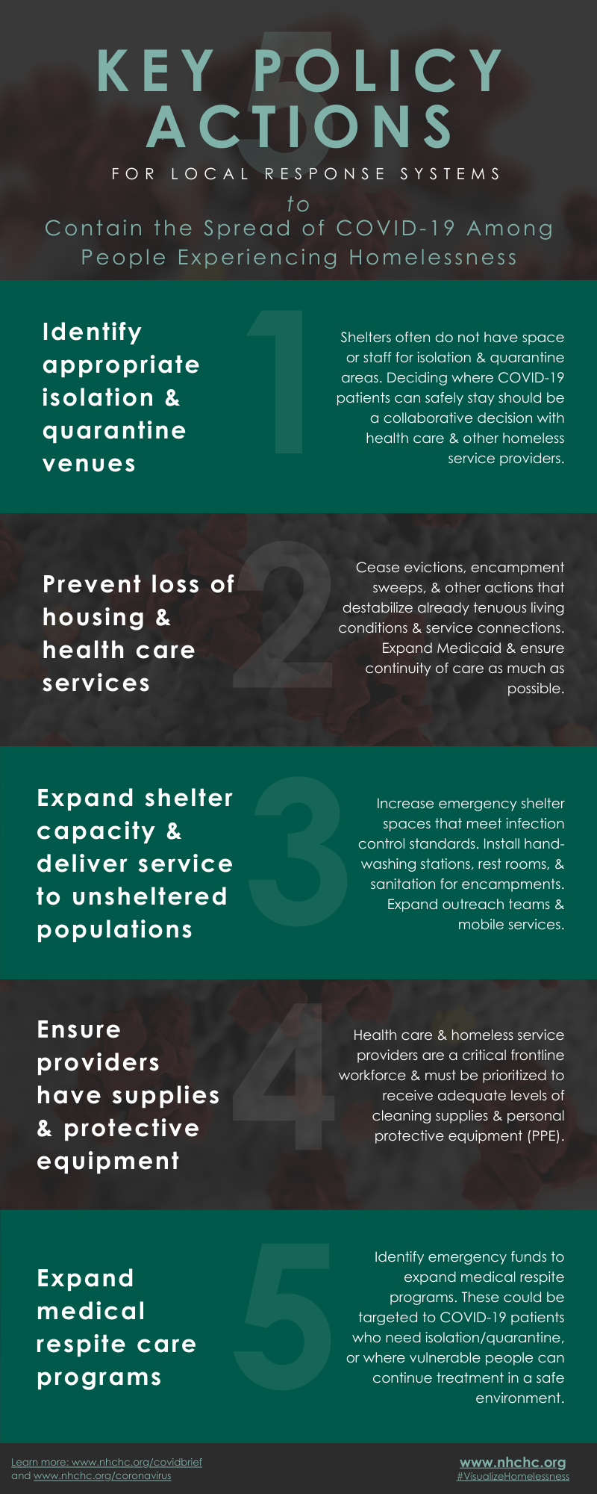

VIII. Sustaining High Standards of Care for People Experiencing Homelessness
Add this section
A. What defines success in Shelter-Based Care
B. What’s needed to make this sustainable and achieve long-term priorities
- Extending HCH resources for shelter-based care
- Business models and policies/incentives
C. Inevitable tradeoffs and prioritization
D. Leadership from people with lived experience
Consumer Advisory: the only way to understand the needs of those experiencing homelessness is to give them a voice in planning and implementing services. PEH should be involved at all levels of new projects
E. Governance, communication, and transparency
F. Addressing common challenges in engaging partners – strategies to include braided funding
G. Prescription discounts and process for making that work
H. Care coordination with individuals who are tough to get in touch with

IX. Resources
Learning modules, including: HCH 101 https://nhchc.org/online-courses/hch-101/hch-101-course/
Adapted clinical standards
- https://nhchc.org/clinical-practice/homeless-services/interdisciplinary-care/
- https://nhchc.org/clinical-practice/homeless-services/case-management/
- https://nhchc.org/clinical-practice/diseases-and-conditions/influenza/

